**Project Report**

**AE681A**

COMPOSITE MATERIALS

**AMAL M S**

**22101262**

**Ph.D. - AE**

**CONTENTS**

* **Question**
* **Abaqus Modelling**
* **Observations/Outputs**
  + **Strength of materials approach**
  + **Standard Mechanics approach**
  + **Reuss and Voigt approximation**
  + **CCA**
  + **Hashin strikman**
  + **Halpin Tsai**
  + **Self Consistent**
  + **Mori Tanaka**
* **Conclusion**
* **Attachments:**
  + **MATLAB code**
    - **Strength of materials approach**
    - **Standard Mechanics approach**
    - **Reuss and Voigt approximation**
    - **CCA**
    - **Hashin strikman**
    - **Halpin Tsai**
    - **Self Consistent**
    - **Mori Tanaka**
  + **ABAQUS CAE File**

**QUESTION**

**Given Material Properties of Fiber and Matrix**

**Material ID – 7**

|  |  |
| --- | --- |
| Fibre type | E-glass 21xK43 Gevetex |
| Longitudinal modulus, E1 (GPa) | 80 |
| Transverse modulus, E2 (GPa) | 80 |
| In-plane shear modulus, G12 (GPa) | 33.33 |
| Major Poisson’s ratio, ν12 | 0.2 |
| Transverse shear modulus, G23 (GPa) | 33.33 |
| Longitudinal thermal coefficient, α1 (10−6 /°C) | 4.9 |
| Transverse thermal coefficient, α2 (10−6 /°C) | 4.9 |

|  |  |
| --- | --- |
| Matrix type | MY750/HY917/ DY063 epoxy |
| Modulus, Em (GPa) | 3.35 |
| Poisson’s ratio, νm | 0.35 |
| Thermal coefficient, αm (10−6 /°C) | 58 |

**Volume Fraction – 0.5**

**Load – Displacement**

**ABAQUS MODELING**

**Matrix:**

**Dimensions:**

**Length = breadth = Height = 2 mm**

**Fibre:**

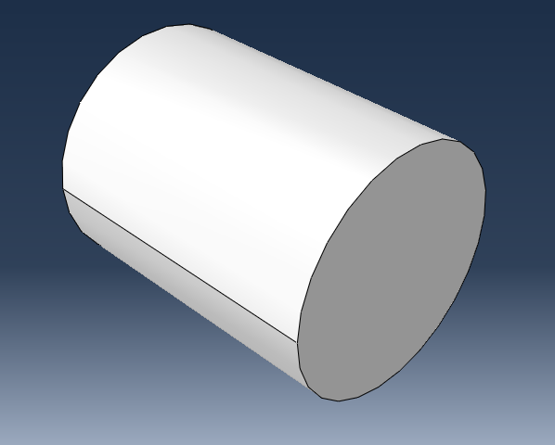

**Dimensions:**

**Length – 2 mm**

**Volume fraction = 0.5**

**Thus, Radius = $\frac{2}{\sqrt{2π}}$ = 0.79788456 mm**

**Assembly:**

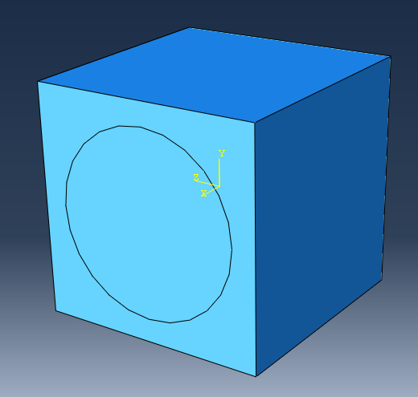

**Merge the two objects in the assembly such that the intersecting boundaries are retained**

**Assigning properties:**

**Fibre:**

**E1 = 80000**

**E2 = 80000**

**E3 = 80000**

**Nu12 = 0.2**

**Nu13 = 0.2**

**Nu23 = 0.2**

**G12 = 33330**

**G13 = 33330**

**G23 = 33330**

**Alpha1 = 4.9*10^-6**

**Alpha2 = 4.9*10^-6**

**Matrix:**

**E = 3350**

**Nu = 0.35**

**Alpha = 58*10^-6**

**Mesh**

**Apply loads to obtain the following outputs (Ref: attached files)**

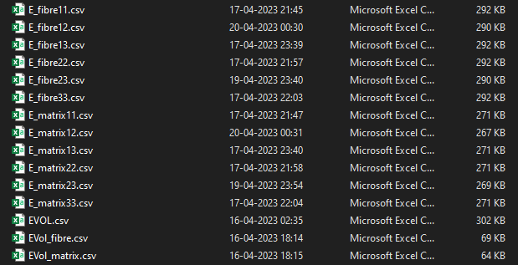

**OBSERVATIONS**

1. **Strength of Materials Approach:**

**E1 vs Vf**

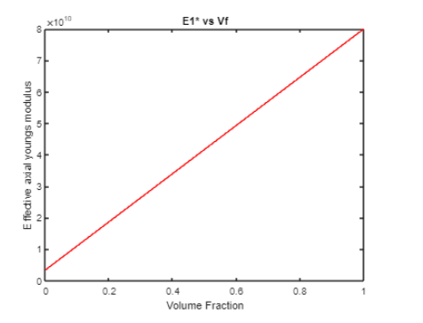

**V21  vs Vf**

**E2 vs Vf  (1. when deformation in direction 1 is not considered and 2. when deformation in direction 1 is also considered)**

**

**G12 vs Vf**

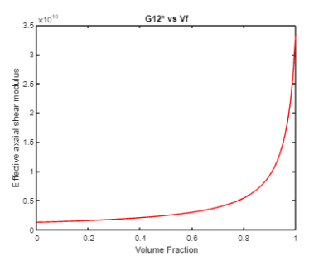

**Alpha vs Vf**

1. **CCA:**

**E1 vs Vf**

**V21  vs Vf**

**G12 vs Vf**

**G23 vs Vf (3 phase model)**

**K 23 vs Vf**

1. **Voigt and Reuss Approximation**

**E1 vs Vf**

**E2 vs Vf**

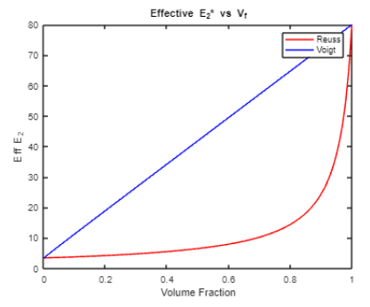

**G12 vs Vf**

**G23 vs Vf**

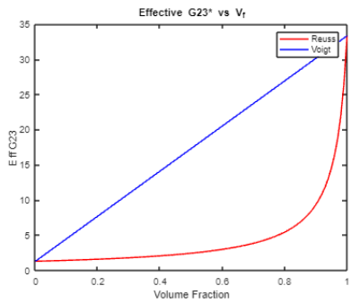

**v12 vs Vf**

**v23 vs Vf**

1. **SELF CONSISTENT METHOD**

**G12 vs Vf**

**G23 vs Vf**

**Since, G23 = 0 throughout in this method, other properties which are dependent on G23 through the implicit relations will also be inaccurate. Hence not included here.**

1. **MORI TANAKA METHOD**

**G12 vs Vf**

**G23 vs Vf**

**E1 vs Vf**

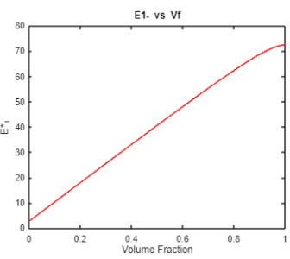

**v12 vs Vf**

**E2 vs Vf**

**v23 vs Vf**

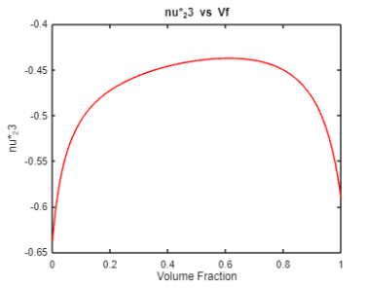

1. **Halpin Tsai Method**

**E1 vs Vf**

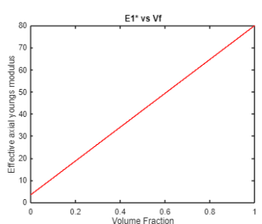

**v12 vs Vf**

**M vs Vf**

1. **Hashin Strickman Bounds**

**E1 vs Vf**

**v12 vs Vf**

**G12 vs Vf**

**G23 vs Vf**

**E2 vs Vf**

**v23 vs Vf**

1. **Hills Concentration Factor Approach**

**CONCLUSION / INFERENCE**

* **Self consistent method could not be successfully employed to calculate the effective properties as the Solution of the implicit equation for G23 was giving complex roots. Since some of the other quantities were dependent on the value of G23, more than one quantity was unable to be found out.**
* **G23 for 3 phase model could be calculated for volume fractions of fibre upto around 0.5. After which it showed complex values.**

* **The upper and lower bounds of Hashin Strickman method to find out E1 almost coincides and is linear.**
* **E2 and v23 in Hashin strickman method shoots up at around a volume fraction of fibre: 0.2.**
* **The bounds in Effective properties can be clearly visualised in case of Hashin Strickman and Voigt-Reuss Approximation.**